Exception Handling in SQL Server

An error condition during a program execution is called an exception and the mechanism for resolving such an exception is known as exception handling. In this article, we will learn how to implement exception handling in SQL Server. SQL Server provides TRY, CATCH blocks for exception handling. We can put all T-SQL statements into a TRY BLOCK and the code for exception handling can be put into a CATCH block. We can also generate user-defined errors using a THROW block.

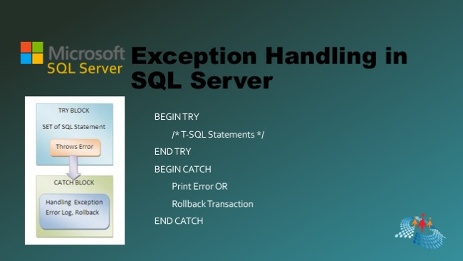

## **Syntax of Exception Handling**

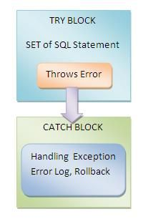  
  
BEGIN TRY/* T-SQL Statements */END TRYBEGIN CATCH- Print Error OR- Rollback TransactionEND CATCH  
  
In exception handling all T-SQL statements are put into a try block. If all statements execute without any error then everything is OK else control will go to the catch block.

## **Types of SQL Server Exceptions**

SQL Server contains the following two types of exceptions:

1. System Defined
2. User Defined

### **System Defined Exception**

In a System Defined Exception the exceptions (errors) are generated by the system.  
  
**Example**

Declare @val1 int;

Declare @val2 int;

BEGIN TRY

Set @val1=8;

Set @val2=@val1/0; /* Error Occur Here */

END TRY

BEGIN CATCH

Print 'Error Occur that is:'

Print Error_Message()

END CATCH

**Output**

Error Occur that is:Divide by zero error encountered

## **User Defined Exception**

This type of exception is user generated, not system generated.

**Declare** @val1 **int**;

**Declare** @val2 **int**;

**BEGIN** TRY

**Set** @val1=8;

**Set** @val2=@val1%2;

if @val1=1

Print ' Error Not Occur'

**else**

**Begin**

Print 'Error Occur';

Throw 60000,'Number Is Even',5

**End**

**END** TRY

**BEGIN** CATCH

Print 'Error Occur that is:'

Print Error_Message()

**END** CATCH

**Output**

Error OccurError Occur that is:Number Is Even

Here 60000 denotes the error number and 5 denotes the state to associate with the message.  
  
The following are system functions and the keyword used within a catch block:

1. @@ERROR
2. ERROR_NUMBER()
3. ERROR_STATE()
4. ERROR_LINE()
5. ERROR_MESSAGE()
6. ERROR_PROCEDURE()
7. ERROR_SEVERITY()
8. RAISERROR()
9. GOTO()

These functions include the following:

1. ERROR_MESSAGE() - you can take advantage of this function to get the complete error message.
2. ERROR_LINE() - this function can be used to get the line number on which the error occurred.
3. ERROR_NUMBER() - this function can be used to get the error number of the error.
4. ERROR_SEVERITY() - this function can be used to get the severity level of the error.
5. ERROR_STATE() - this function can be used to get the state number of the error.
6. ERROR_PROCEDURE() - this function can be used to know the name of the stored procedure or trigger that has caused the error.

Now we will see some examples to help understand all these functions and keywords.  
  
First create a table and enter some value into the table as in the following:

**Create** **TABLE** Employee

(

Emp_IId **Int** identity(1,1),

First_Name Nvarchar(**MAX**) Not NUll,

Last_Name Nvarchar(**MAX**) Not Null,

Salary **Int** Not Null **check**(Salary>20000),

City Nvarchar(**Max**) Not Null

)

Insert data into Employee.

**Select** 'Pankaj','Choudhary',25000,'Alwar' **Union** All

**Select** 'Rahul','Prajapat',23000,'Alwar' **Union** All

**Select** 'Sandeep','Jangid',27000,'Alwar' **Union** All

**Select** 'Sanjeev','Baldia',24000,'Alwar' **Union** All

**Select** 'Neeraj','Saini',22000,'Alwar' **Union** All

**Select** 'Narendra','Sharma',23000,'Alwar' **Union** All

**Select** 'Divyanshu','Gupta',25000,'Alwar'

Now execute a select command.

1. **Select** * **From** Employee

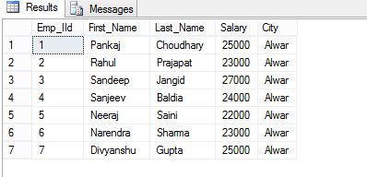

**Example for All Error details:**

BEGIN TRY

Insert Into Categories(CategoryID, CategoryName, Description, Picture) Values (9, 'Test', 'Test Description', 'Test')

END TRY

BEGIN CATCH

SELECT ERROR_MESSAGE() AS [Error Message]

,ERROR_LINE() AS ErrorLine

,ERROR_NUMBER() AS [Error Number]

,ERROR_SEVERITY() AS [Error Severity]

,ERROR_STATE() AS [Error State]

END CATCH

**Example 1: (@@ERROR)**  
@@ERROR return the error number for last executed T-SQL statements. It returns 0 if the previous Transact-SQL statement encountered no errors else return an error number.

**Update** Employee **set** Salary=19000 **Where** Emp_IID=5

IF @@ERROR = 547

PRINT 'A check constraint violation occurred.';

**Output:**

Msg 547, Level 16, State 0, Line 1

The UPDATE statement conflicted with the CHECK constraint "CK__Employee__Salary__68487DD7". The conflict occurred in database "Home_Management", table "dbo.Employee", column 'Salary'.

The statement has been terminated.  
  
**A check constraint violation occurred.**  
  
**Example 2 (ERROR_NUMBER)**  
ERROR_NUMBER() returns the error number that caused the error. It returns zero if called outside the catch block.

**BEGIN** TRY

**Update** Employee **set** Salary=19000 **Where** Emp_IID=5

**END** TRY

**BEGIN** CATCH

**SELECT** ERROR_NUMBER() **AS** ErrorNumber;

**END** CATCH;

GO

**Output**  
  
catch block  
Now a question develops of what is diff @@ERROR and ERROR_NUMBER. Let me explain.

1. ERROR_NUMBER can only be used in a catch block, outside a catch block it returns Null but @@ERROR can be used inside or outside the catch block (see Example 1).
2. ERROR_NUMBER is a contrast to @@ERROR, that only returns the error number in the statement immediately after the one that causes an error, or the first statement of a CATCH block.

Now we will see an example and observe the differences between them.

**BEGIN** TRY

**Update** Employee **set** Salary=19000 **Where** Emp_IID=5

**END** TRY

**BEGIN** CATCH

**SELECT** ERROR_NUMBER() **AS** ErrorNumber;

print @@ERROR

**END** CATCH;

GO

**Output**  
  
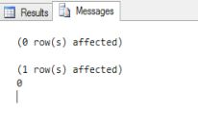

**BEGIN** TRY

**Update** Employee **set** Salary=19000 **Where** Emp_IID=5

**END** TRY

**BEGIN** CATCH

print @@ERROR

**SELECT** ERROR_NUMBER() **AS** ErrorNumber;

**END** CATCH;

GO

**Output**  
  
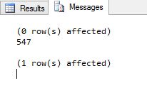  
**Example 3 (ERROR_MESSAGE)**  
ERROR_MESSAGE returns the message text of the error that caused the error. The return type of ERROR_MESSAGE is **nvarchar(4000)**.

**BEGIN** TRY

**Update** Employee **set** Salary=19000 **Where** Emp_IID=5

**END** TRY

**BEGIN** CATCH

**SELECT** ERROR_MESSAGE() **AS** ErrorMsg;

**END** CATCH;

GO

**Output**

The UPDATE statement conflicted with the CHECK constraint "CK__Employee__Salary__68487DD7". The conflict occurred in database "Home_Management", table "dbo.Employee", column 'Salary'.

**Example 4 ( ERROR_STATE)**  
ERROR_STATE returns the state number of the error. The return type of ERROR_STATE is **INT**.

**BEGIN** TRY

**SELECT** SALARY + First_Name **From** Employee **Where** Emp_IID=5

**END** TRY

**BEGIN** CATCH

**SELECT** ERROR_STATE() **AS** ErrorState , ERROR_MESSAGE() ErrorMsg ;

**END** CATCH;

GO

**Output**  
  
INT  
  
**Example 5 (ERROR_LINE)**  
ERROR_LINE returns the line number at which an error occurred. The return type of ERROR_LINE is **INT**.

**BEGIN** TRY

**SELECT** SALARY + First_Name **From** Employee **Where** Emp_IID=5

**END** TRY

**BEGIN** CATCH

**SELECT** ERROR_STATE() **AS** ErrorLine;

**END** CATCH;

GO

**Output**  
  
ERROR LINE  
**Example 6 (ERROR_PROCEDURE)**  
ERROR_PROCEDURE returns the name of the Stored Procedure or trigger of where an error occurred. The return type of ERROR_PROCEDURE is **nvarchar(128)**.  
  
**Return value**  
Return value returns the Stored Procedure Name if an error occurs in a Stored Procedure or trigger and the catch block is called.  
  
It returns **NULL** if the error did not occur within a Stored Procedure or trigger or it isb called outside the scope of a CATCH block.  
  
First we create a Stored Procedure.

**Create** **Procedure** My_Proc

**AS**

**begin**

**BEGIN** TRY

**SELECT** SALARY + First_Name **From** Employee **Where** Emp_IID=5

**END** TRY

**BEGIN** CATCH

**SELECT** ERROR_PROCEDURE() **AS** ProcName;

**END** CATCH;

**END**

Now execute this Stored Procedure.

1. **Exec** My_Proc

**Output**  
  
execute this Stored Procedure  
  
**Example 7 (ERROR_SEVERITY)**  
ERROR_SEVERITY returns the severity of the error. The return type of ERROR_SEVERITY is **INT**.

**BEGIN** TRY

**SELECT** SALARY + First_Name **From** Employee **Where** Emp_IID=5

**END** TRY

**BEGIN** CATCH

**SELECT** ERROR_SEVERITY() **AS** ErrorSeverity;

**END** CATCH;

**Output**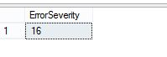  
  
The severity level of an error message provides an indication of the type of problem that Microsoft® SQL Server encountered. In the preceding example the Severity Level is 16. That means that the error can be removed by the user.  
  
Some important severity levels are:

|  |  |
| --- | --- |
| 13 | Indicates transaction deadlock errors. |
| 14 | Indicates security-related errors, such as permission denied. |
| 15 | Indicates syntax errors in the Transact-SQL command. |
| 16 | Indicates general errors that can be corrected by the user. |

**Example 8 (RAISERROR)**  
RAISEERROR is used to generate an error message and initiates error processing for the session.

**BEGIN** TRY

**SELECT** SALARY + First_Name **From** Employee **Where** Emp_IID=5

**END** TRY

**BEGIN** CATCH

RAISERROR(N'An Error Is Occur',16,3);

**END** CATCH;

**Output**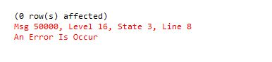  
In RAISERROR(N'An Error Is Occur',16,3) the first argument represents the error messagethe , second argument represents the Severity Level and the last argument represents the Error State.  
  
**Example 9 (GOTO)**  
GOTO causes a jump to a specific step or statement. It alters the flow of execution to a label. We declare some labels in batch and alter we can move at a specific label. GOTO can exist within a conditional control-of-flow statements, statement blocks, or procedures, but it cannot go to a label outside the batch. GOTO cannot be used to jump into a TRY or CATCH scope.

**Declare** @Var **Int**;

**Set** @Var=1

Print 'Goto exercise'

If @Var%2=0

**GOTO** Label1;

**else**

**GOTO** Label2;

**Set** @Var=@Var+1;

Label1:

Print 'Var Is Odd'

Label2:

Print 'Var Is Even'

**Output**

Goto exerciseVar Is Even

**Example 10**

**BEGIN** TRY

**SELECT** SALARY + First_Name **From** Employee **Where** Emp_IID=5

**END** TRY

**BEGIN** CATCH

**SELECT** ERROR_STATE() **AS** Error_Stat,ERROR_SEVERITY() **AS** ErrorSeverity, ERROR_LINE() **as** ErrorLine, ERROR_NUMBER() **AS** ErrorNumber, ERROR_MESSAGE() **AS** ErrorMsg;

**END** CATCH;

**Output**  
  
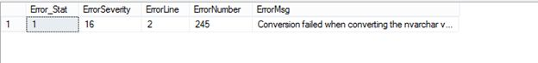  
  
**Exercise 11 (Transaction Management)**  
  
Exception handling is mainly used for Transaction Management. Let us see an example.

**Begin** **Transaction** Trans

**Begin** Try

**Delete** **From** Employee **Where** Employee.Emp_IID<3

**Update** Employee **Set** Employee.First_Name='Pankaj kumar' **Where** Employee.Emp_IID='6th' /* Error Will Occur Here */

      If @@TranCount>0

**begin** **Commit** **Transaction** Trans

**End**

**End** Try

**Begin** Catch

   if @@TranCount>0

   Print 'Error Is Occur in Transaction'

**begin** **Rollback** **Transaction** Trans

**End**

**End** Catch

**Select** * **From** Employee

**Output**  
  
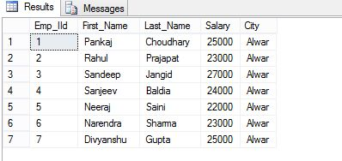  
  
When to use Exception Handling:

1. In Transaction Management to Rollback the transaction.
2. While using cursors in SQL Server.
3. When implementing a DML Query (insert, update or delete) for for an checking the error and to handle it